

**ONLINE CAR RENTAL SYSTEM**

**A Major Project Report submitted in partial fulfilment**

**of**

**the requirements**

**For the Degree**

**Of**

**B. Tech in Computer Science Engineering**

**Submitted by**

**Mr. Bharadwaj Nayak (1901298095)**

**Mr. Sahil Kumar Dhala (1901298183)**

**Mr. Satya Sundar Moharana (1901298192)**

**Under the guidance of**

**Mr. Priyabrata Nayak**

**(Asst. Prof. Dept of Software Development)**

**Gandhi Institute For Technology, Bhubaneswar**

**For the Session**

**2022-2023**

**BIJU PATNAIK UNIVERSITY OF TECHNOLOGY, ODISHA**



**DEPARTMENT OF COMPUTER SCIENCE ENGINEERING**

**Gandhi Institute For Technology (GIFT), Bhubaneswar Affiliated to**



**ONLINE CAR RENTAL SYSTEM**

**A Major Project Report submitted in partial fulfilment of the requirements**

**For the Degree**

**Of**

**B. Tech in Computer Science Engineering**

**Submitted by**

**Mr. Bharadwaj Nayak (1901298095)**

**Mr. Sahil Kumar Dhala (1901298183)**

**Mr. Satya Sundar Moharana (1901298192)**

**Under the guidance of**

**Mr. Priyabrata Nayak**

**(Asst. Prof. Dept of Software Development)**

**Gandhi Institute For Technology, Bhubaneswar**

**For the Session**

**2022-2023**

**BIJU PATNAIK UNIVERSITY OF TECHNOLOGY, ODISHA**



**DEPARTMENT OF COMPUTER SCIENCE ENGINEERING**

**Gandhi Institute For Technology (GIFT), Bhubaneswar Affiliated to**



**Mr. Bharadwaj Nayak (1901298095)**

**Mr. Sahil Kumar Dhala (1901298183)**

**Mr. Satya Sundar Moharana (1901298192)**

we, Mr. Bharadwaj Nayak, Mr. Sahil Kumar Dhala, and Mr. Satya Sundar Moharana hereby declare that this written submission represents our ideas in our own words and where other’s ideas or words have been included; it has been adequately cited and referenced the original sources. We also declare that we have adhered to all the principles of academic honesty and integrity and have not misrepresented or fabricated or falsified any idea/ data/fact/source in our submission. We understand that any violation of the above will be cause for disciplinary action by the institute and can also evoke penal action from the sources which have thus no been properly cited or from whom proper permission has not been taken when needed.

**DEPARTMENT OF COMPUTER SCIENCE ENGINEERING**

**Gandhi Institute For Technology (GIFT), Bhubaneswar**

**Affiliated to (BIJU PATNAIK UNIVERSITY OF TECHNOLOGY, ODISHA)**

**DECLARATION**



**Prof. Smruti Smaraki Sarangi**

**PROJECT COORDINATOR**

**EXTERNAL EVALUATOR**

**EXTERNAL EVALUATOR**

**Dr. Sujit Panda**

**HOD, CSE**

**Mr. Priyabrata Nayak**

**PROJECT GUIDE**

**CERTIFICATE**

This is to certify that the project work titled “ONLINE CAR RENTAL SYSTEME” is a bonafide record of the work done by **Mr. Bharadwaj Nayak(1901298095), Mr. Sahil Kumar Dhala(1901298183), Mr. Satya Sundar Moharana(1901298192)** in partial fulfilment of the requirements for the award of the degree B. Tech Computer Science Engineering from the Gandhi Institute For Technology (GIFT) under BIJU PATNAIK UNIVERSITY OF TECHNOLOGY (BPUT), ODISHA.

**DEPARTMENT OF COMPUTER SCIENCE ENGINEERING**

**Gandhi Institute For Technology (GIFT), Bhubaneswar**

**Affiliated to (BIJU PATNAIK UNIVERSITY OF TECHNOLOGY, ODISHA)**



**Mr. Bharadwaj Nayak (1901298095)**

**Mr. Sahil Kumar Dhala (1901298183)**

**Mr. Satya Sundar Moharana (1901298192)**

**DECLARATION**

We, Mr. Bharadwaj Nayak, Mr. Sahil Kumar Dhala, Mr. Satya Sundar Moharana hereby

declare that this written submission represents our ideas in our own words and where other’s ideas or words have been included; it has been adequately cited and referenced the original sources. We also declare that we have adhered to all the principles of academic honesty and integrity and have not misrepresented or fabricated or falsified any idea/ data/fact/source in our submission. We understand that any violation of the above will be cause for disciplinary action by the institute and can also evoke penal action from the sources which have thus not been properly cited or from whom proper permission has not been taken when needed.

**DEPARTMENT OF COMPUTER SCIENCE ENGINEERING**

**Gandhi Institute For Technology (GIFT), Bhubaneswar**

**Affiliated to (BIJU PATNAIK UNIVERSITY OF TECHNOLOGY, ODISHA)**



**Mr. Bharadwaj Nayak (1901298095)**

**Mr. Sahil Kumar Dhala (1901298183)**

**Mr. Satya Sundar Moharana (1901298192)**

**DEPARTMENT OF COMPUTER SCIENCE ENGINEERING**

**Gandhi Institute For Technology (GIFT), Bhubaneswar**

**Affiliated to (BIJU PATNAIK UNIVERSITY OF TECHNOLOGY, ODISHA)**

**ACKNOWLEDGMENT**

I am grateful to **Mr. PRIYABRATA NAYAK** Project guide, Gandhi Institute For Technology, Bhubaneswar, for the assigning me this innovation project and modeling us both technically and morally for achieving success in life.

It is great senses of satisfaction that my first real live venture in practical computing is in the form of project work. I extend my humble obligation towards **Dr. SATYA RANJAN PATTANAIK**, H.O.D, Dept. Of Computer Science & Engineering, Centre for Post Graduate Studies, GIFT for providing us with an environment to study and build our career.

Above all, I thank the almighty without whose grace and blessings. I would not have been able to complete my work successfully.

**Content**

**Abstract**

**1.INTRODUTION ……………………………………………………………..9**

**2.LITERATURE REVIEW.…………………………………………….10,11**

**3.PROJECT OBJECTIVE…………………………………………………………………………………12**

**4.SCOPE OF THE PROJECT………………………………………………12**

**5.MODULE DESCRIPTION……………………………………………………………………………13**

**5.1. Admin Module…………………………………………………………………………..13**

**5.2. User Module……………………………………………………….13**

**6.SOFTWARE QUALITY ATTRIBUTES…………………………………………………………….14**

**7.SYSTEM REQUIREMENTS……………………………………………...14**

**7.1. Hardware Requirement…………………………………………..14**

**7.2. Software Requirement……………………………………………14**

**8.E-R DIAGRAM…………………………………………………………14,15**

**9.NORMALIZATION………………………………………………………..16**

**10.SYSTEM DESIGN………………………………………………………...16**

**10.1. Data Flow Diagram…………………………………………..17,18**

**10.2. Use Case Diagram…………………………………………….19,20**

**10.3. Sequence Diagram…………………………………………….21,22**

**11.DATA DESIGN……………………………………………………..…23,24**

**12.SCREEN SHORTS……………………………………………………25-27**

**13.SOFTWARE TESTING…………………………………….28-31**

**14.CONCLUTION…………………………………………………32**

**15.REFERENCES………………………………………33**

**ABSTRACT**

Our Aim is to design and create a data management System for an online car rental company. This enables admin to rent a vehicle that can be used by a customer, by paying the money for a specified period of time. This system increases customer retention and simplify vehicle and staff Management in an efficient way. This software**, Online car Rental System (OCRS)** has a very user-friendly interface, it will be easy for the users to this application. By using OCRS the admin can manage their rental, Bookings, customer issues and vehicle issues etc. The car information can be added to the system. or existing car information can be edited or deleted too by the Admin. The transaction reports of the OCRS can be retrieved by the admin, when its required. Thus, there is no delay in the availability of any car information, whenever needed the car information can be Captured very quickly and easily. This software was developed based on **Software Development Life Cycle (SDLC)** using the waterfall model as a methodology. A user acceptance testing will be conducted with thirty (30) respondents to determine the effectiveness of the system by evaluating the questionnaire which was categorized into four parts includes user interface design, usefulness, usability and alert system function. New User can Register through all detail on Registration page. After that user can login with valid email-id and Password. Then user can choose their comfort car and booked. User will input the date of which day he/she need and how many days. Then the book is conformed then the admin will be see the user request then approved that request. User will be took that Car on date and followed some guidance and some policy of car insurance.

Keyword:- **Web-based system, Online car rental system, SDLC, user acceptance test**.

**1.INTRODUTION**

Online Car Rental Systems are used mostly in developed countries such as USA, England and Australia where electronic commerce has been fully accepted in the society. The online rental car system (OCRS) has made It possible for people to rent a car from specific areas/places. The benefits of these services are numerous, but the most important include convenience and being able to avoid the inconvenience and frustrations of renting a car.

Enterprise recently created a new system of car rentals that allows customers to rent cars without ever leaving their homes. This system is meant for those who live outside of major airports, and who would prefer a more affordable option. With the number of rental cars reaching an all-time high and the online rental car company market expanding, it's clear that the time is right for the next breakthrough in the car rental market.

Car rental service increasingly becomes the preferred option for most people, especially among students in campuses and universities. This occurs because not all students can afford having their own vehicle and perhaps the university bus service doesn’t always help. Besides, the raising taxi fares and inconsistent bus arrivals in Malaysia continue to discourage people from taking up the public transport. Many organizations used web-based system because most people often used mobile phone that gives convenience to the users who are familiar with web technology. The technology has been implemented into the wide-range different sectors, such as education.

 The user has the ability to register and log in to the web site and see their rental plan. The web site will be responsive, allowing for the customer to view it on any device, from tables to mobile phones and desktop computers. The administrator will also be able to login through the same from but have the ability to add/remove new car rentals, change prices, and so on.

Car rental is a service that is offered online. You can rent a car and drop it off at a different location. If you are looking for a new car, OCRS.com offers a huge selection of new and used cars.

**2.LITERATURE REVIEW**

As our structure relies upon the useful Car Renting System which is an authentic application, we inspected the present working circumstance of the renting technique. At present renting, organizations are dependent on manual work which consolidates packages of work area work similarly as a human resource. To date we find Cab Services incredibly easy to book, pay, or drop as they have formed their structures into helpful applications similarly as locales. So there is a need to change the arrangement of the Car Renting Service. But, Car rental business, notwithstanding everything, uses the central methodology for Renting a vehicle to a customer as the customer ought to go genuinely at center, the owner will similarly be accessible there and the owner will permit the vehicle with his/her own supported driver.

Our structure and spotlights on renting Self Drive Cars, where the customer with significant License will have the alternative to book similarly as will have the choice to drive his/her own rented vehicle. The customer selection and endorsement are outstandingly straightforward and made with the goal that it makes the structure almost 0% paper vocations. The customer will have the alternative to select and enter his nuances and move remotely from his home, and the association will have the choice to one of his information without even truly meeting the customer.

Hanif and Sagar (2016) had stated that there was demand for Call-a-Cab service offered by Meru Cab. The cab services are proving security through global positioning system (GPS) and women taxi drivers for women passengers especially during night times. According to Harding et al (2016) the auto-rickshaws (three wheelers) are more popular in urban transport before the advent of cars and cabs. Horsu and Yeboah (2015) had argued that driver behaviour have negative impact on customer satisfaction in Ghana. The variables like continuous service, comfort, reliability and affordability have an impact on customer satisfaction with regard to minicab taxi.

According to Lu et al (2015) the self- service mobile technologies helps the commuters to access lot of data about cab services and such technologies had changed the role of both customers and companies. The adoption of call taxi app (CTA) is impacted perceived usefulness, perceived ease of use, subjective norms and perceived playfulness (Peng, Wang, He, Guo, & Lin, 2014). Chen (2014) had explained that mobile apps help both drivers and passengers to find each other. At present the mobile apps are helps the customers to find cabs. In the recent years the car rental industry is growing constantly especially in metropolitan cities in India (Rahman, 2014).

The Meru cabs had become more popular and the demand for its cabs had exceeded that its supply which means technology had created huge demand for organized cab industry. The factors like accessibility, reliability and transparency are primary factors which have attracted customers towards branded cab services like Meru cabs (Vaithianathan & Bolar, 2013). The customer feedback in cab services industry is very important for attaining success in the competitive car rental industry. Upadhyaya (2013) had explained how Meri Cab Company had collected feedback from its customers and enhanced its service quality for sustaining in the business.

According to Lu et al (2015) the self- service mobile technologies help the commuters to access lot of data about cab services and such technologies had changed the role of both consumers and companies. The adoption of call taxi app (CTA) is impacted perceived usefulness, perceived ease of use, subjective norms and perceived playfulness (Peng, Wang, He, Guo, & Lin, 2014). Chen (2014) had explained that mobile apps help both drivers and passengers to find each other. At present the mobile apps are helps the consumers to find cabs. In the recent years the car rental industry is growing constantly especially in metropolitan cities in India (Rahman, 2014).

According to a report by Ken Research – a global aggregator & publisher of Market intelligence research reports, the Indian car rental market’s revenue is projected to grow at a considerable Compound Annual Growth Rate (CAGR) of 35 per cent. Furthermore, this sector is expected to be worth more than INR 800 billion by 2019, which is quite an encouraging aspect for market players in this segment.

As per Advocate Shirish V. Deshpande, Chairman of Mumbai Grahak Panchayat, Ola and Uber will have the lax of fixing their own fares for the passengers, the fares will have minimum and maximum limit thereby preventing the possibility of predatory pricing by Ola and Uber and thereby either killing or distorting the competition. The said rules also put certain restrictions on conduct of the drivers as well as ensure security & safety aspects of the passengers. Also his studies support the competitiveness in multiple cities with respect to pricing, smart prising, car options, payment options and quality of drivers as well as cars.

**3.PROJECT OBJECTIVE**

The project is to design a website that will provide the consumer with an overview of the car rental company, the type of cars they have and the fees associated with renting a car. The website will also be used for car rental marketing and for consumer engagement.

The project is to design a website that will provide the consumer with an overview of the car rental company, the type of cars they have and the fees associated with renting a car. The website will also be used for car rental marketing and for consumer engagement.

The website will provide the consumer with an overview of the car rental company, the type of cars they have and the fees associated with renting a car. The website will also be used for car rental marketing and for consumer engagement.

The website will provide the consumer with an overview the car rental company, the type of cars they have and the fees associated with renting a car. The website will also be used for car rental marketing and for consumer engagement.

The objective of the PROJRCT is to provide an online car rental system that offers the best possible service with the lowest possible price.

**4.SCOPE OF THE PROJECT**

The project aims to create a platform for people with cars to rent them out to people who are in need of short-term rentals. The system will have a range of features, such as insurance and rental terms, which will be customizable by users. With this system, people will be able to rent cars on the go and respond to requests on the go as well.

* **Convenience:** You can get to your destination way easier and quicker than when you use public transportation.
* **Flexibility:** Just drive your car whenever you need and go wherever want. You don’t need to wait for the exact buses and adapt the schedules. Moreover, the GPS technology will make your journey even better - it will be your best guide in route.
* **Additional services:** Most of the rental companies provide additional services making your experience even better and more comfortable. (such as extra equipment, door to door delivery, transfers, group tours etc.)

**5.MODULE DESCRIPTION**

**5.1. Admin Module**

**5.1.1.** Registration:

* User Registration
* Vehicles Registration

**5.1.2.** Booking Operation:

* + - * Booking Confirmation
      * Booking Cancellations

**5.2. User Module**

**5.2.1.** Booking Detail:

* Online Booking

**5.2.2.** Search:

* Vehicles Catalogues
* Booking
* Search Car

**6.SOFTWARE QUALITY ATTRIBUTES**

* **Availability:** The cars should be available on the specified date and specified time as many customers are making immediate booking.
* **Correctness:** The cars should function correctly and should reach the correct destination.
* **Maintainability:** The administrators and car in chargers should maintain correct car availabilities.
* **Usability:** The car models should satisfy a maximum number of customers’ needs.

**7.SYSTEM REQUIREMENTS**

**7.1. Hardware Requirement:**

* **Processor:** Intel Core i3 or Higher/

AMD Processors

* **Ram:** 4GB or Higher (Recommended)
* **Hard Disk:** 50GB or Higher (Recommended)

**7.2. Software Requirement:**

* **User Interface Design:** HTML 5,

CSS 3,Boostrap

* **Software :** XAMPP server
* **Language Used :** PHP
* **Database :** MY SQL
* **Web Browser :** Google Chrome

**8.E-R DIAGRAM**

The E-R Diagram constitutes a technique for representing the logical structure of a database in a pictorial manner. This analysis is then used to organize data as a relation, normalizing relation and finally obtaining a relation 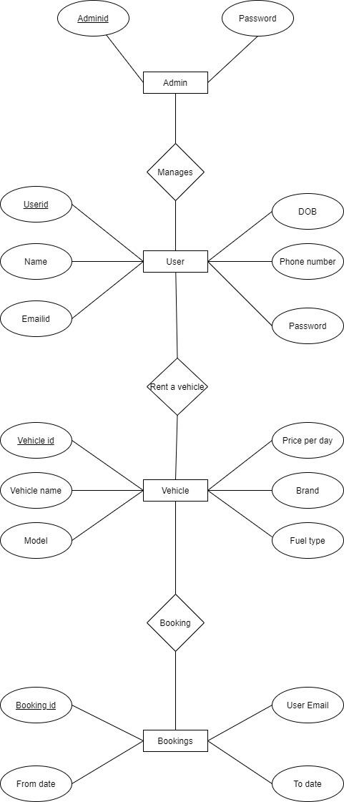database.

**Fig 8.1: E-R MODEL**

**9.NORMALIZATION**

The basic objective of normalization is to reduce redundancy which means that information is to be stored only once. Storing information several times leads to wastage of storage space and increase in the total size of the data stored.

**10.SYSTEM DESIGN**

**10.1. Data Flow Diagram**

* **Context Diagram**

A context diagram, sometimes called a level 0 data-flow diagram, is drawn in order to define.

**Fig.10.1.1: Context diagram of OCRS**

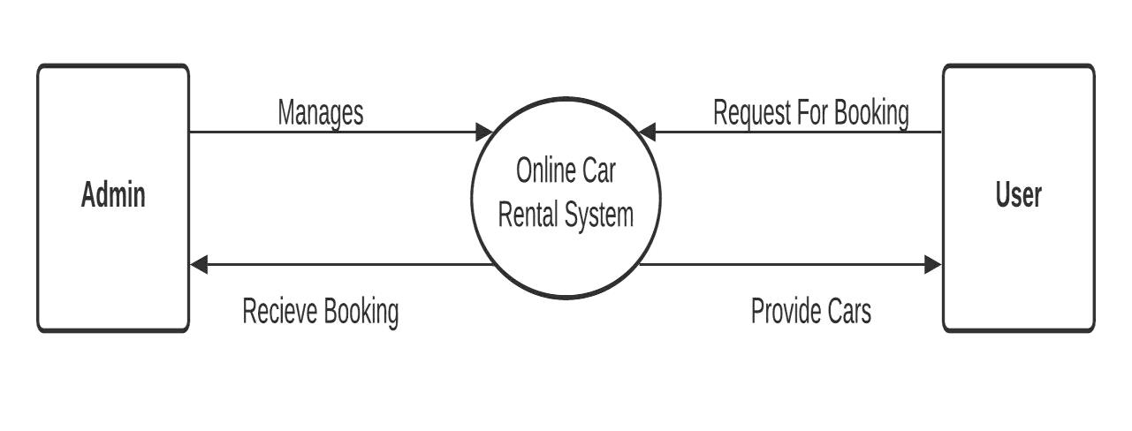

A data-flow diagram is a way of representing a flow of data through a process or a system. The DFD also provides information about the outputs and inputs of each entity and the process itself.

* **Level-1 DFD For OCRS**

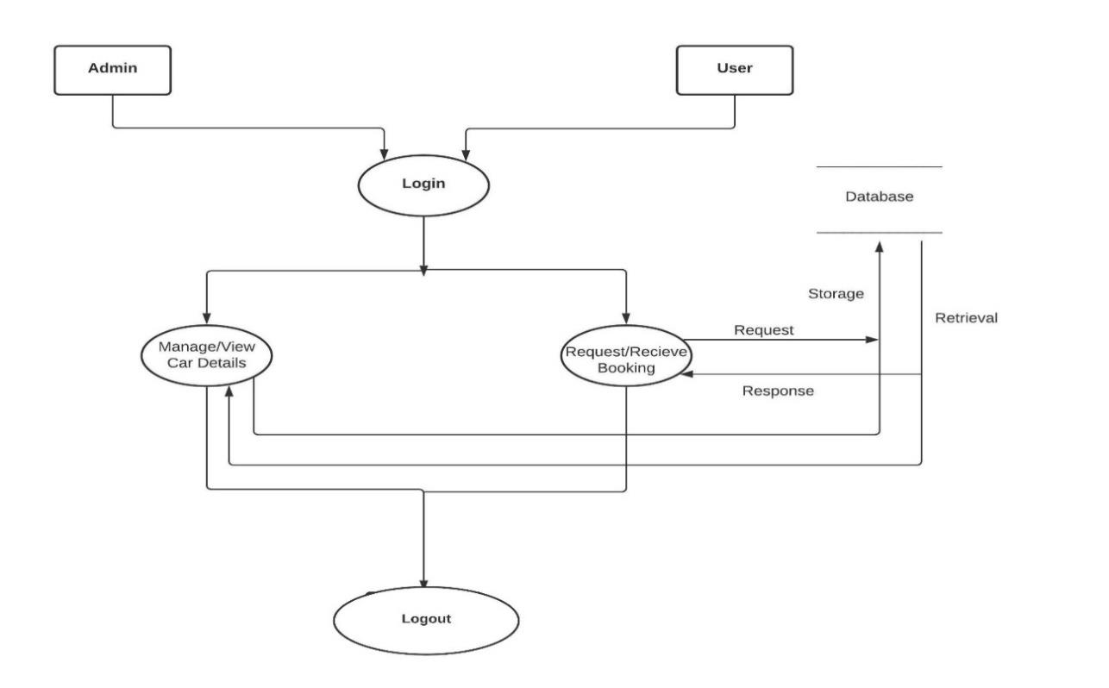

**Fig. 10.1.2: Level 1 Data flow diagram OCRS**

* **Level-2 DFD For Admin**

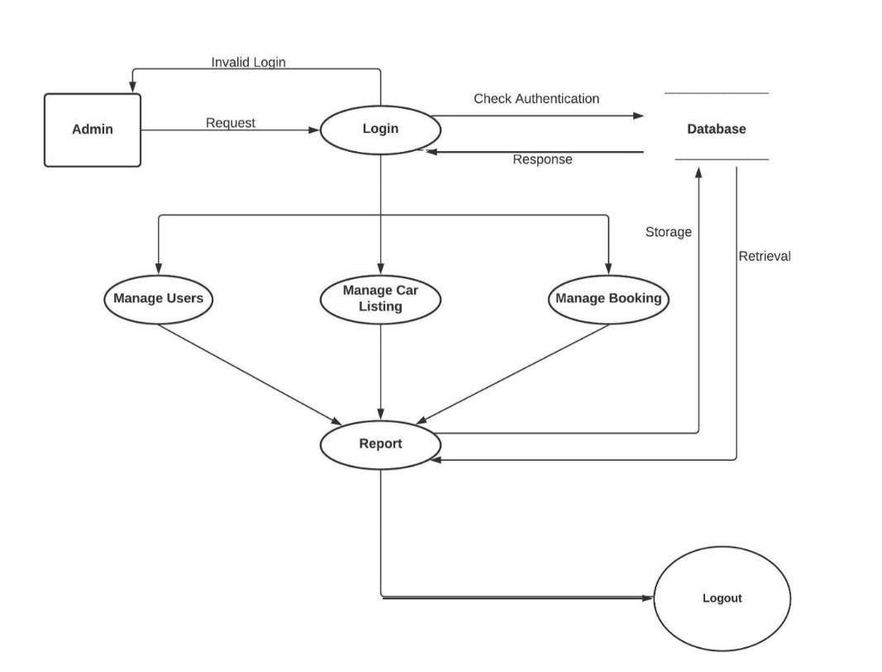

**Fig. 10.1.3: Data flow diagram of Admin**

* **Level-2 DFD For User**

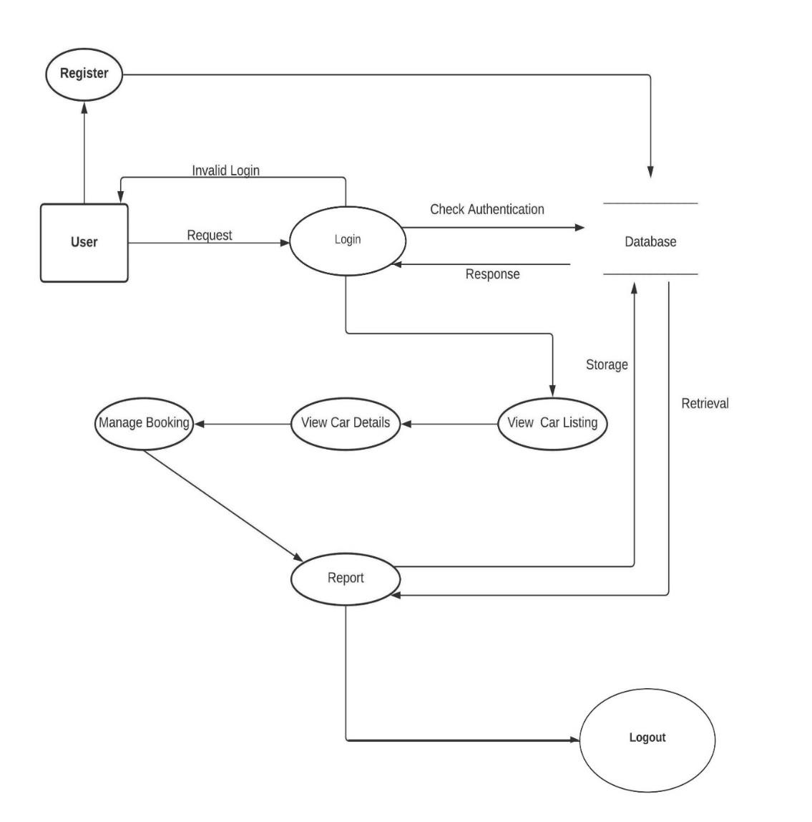

**Fig. 10.1.4: Data flow diagram of User**

**10.2. Use Case Diagram**

This Use Case Diagram is a graphic depiction of the interactions among the elements of Online Car Rental system. It represents the methodology of used in analysis to identify, clarify, and organize system requirements of Online Car Rental System (OCRS).

* 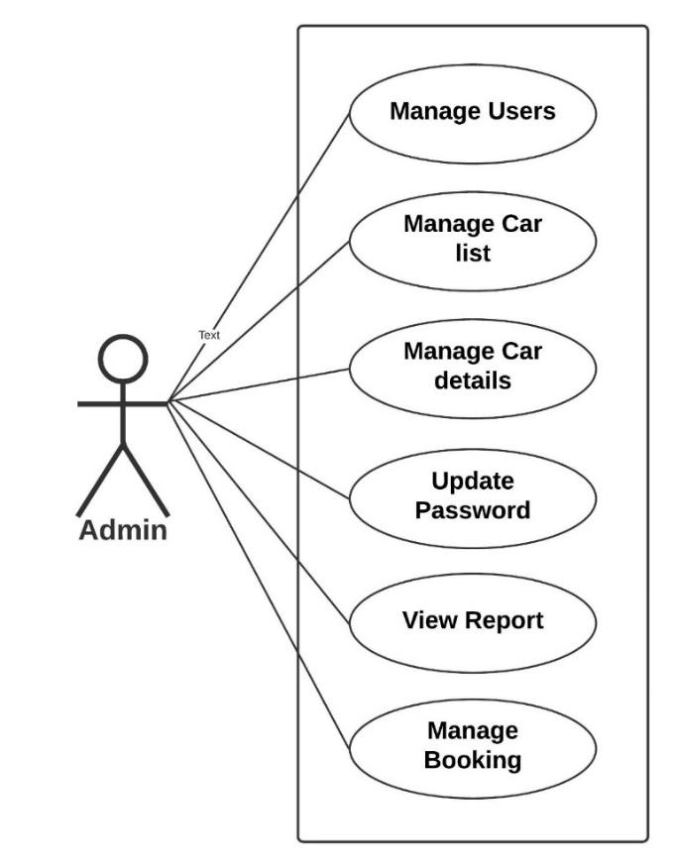 **Use Case of Admin**

**Fig. 10.2.1: Use Case of Admin**

* **Use Case of User**

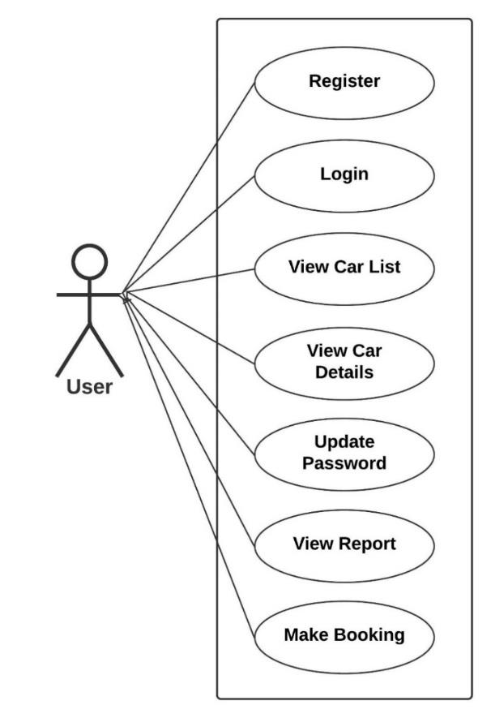

**Fig. 10.2.2: Use Case of User**

**10.3. Sequence Diagram**

This is the UML sequence diagram of Online Car Rental System which shows the interaction between the objects of Drivers, Cars, Passenger, Car Routes, Booking. The instance of class objects involved in this UML Sequence Diagram of Online Car Rental System are as follows: Drivers Object, Car Routes Object, Booking Object.

* 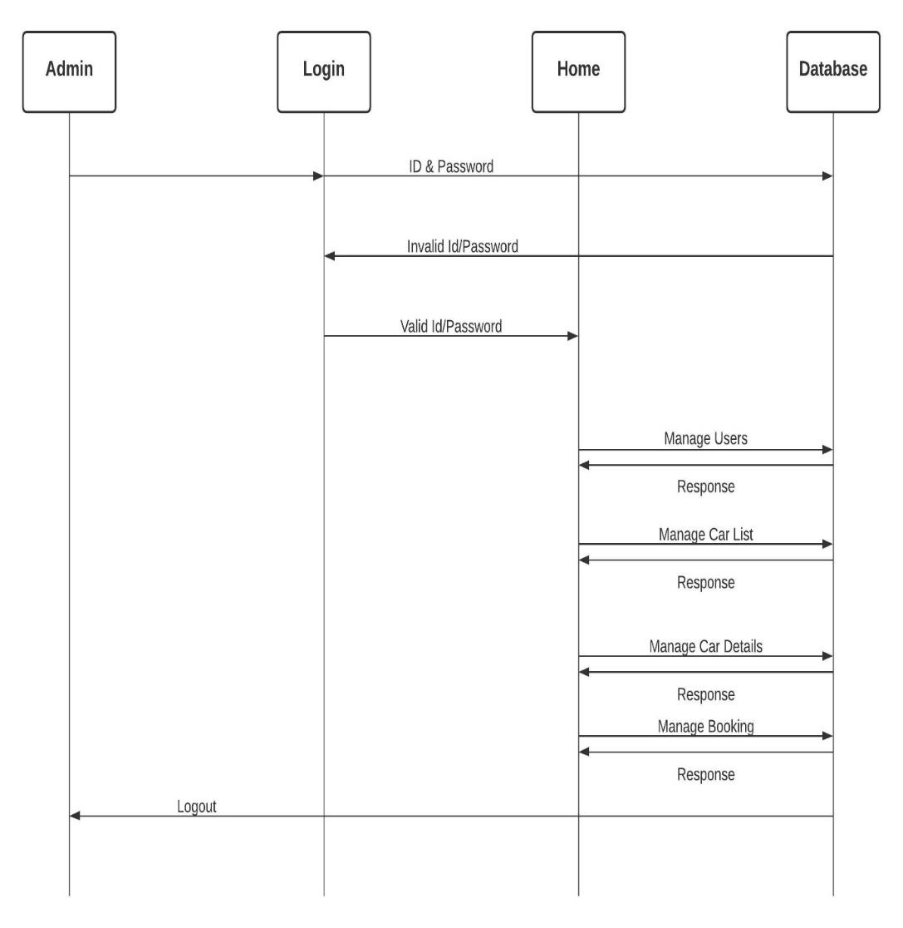**Admin Section**

**Fig. 10.3.1: Sequence Diagram of Admin Section**

* **User Section**

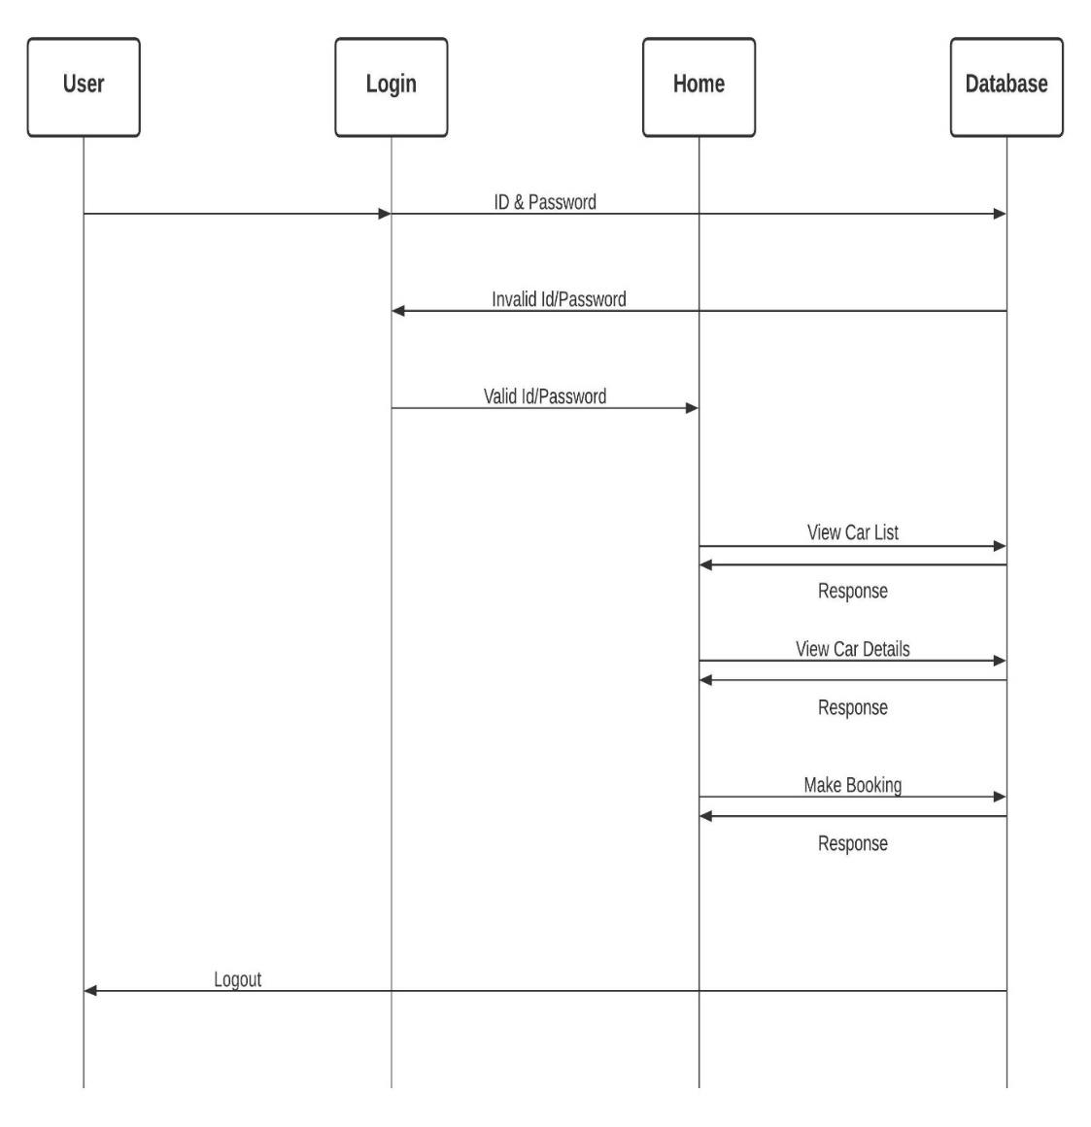

**Fig. 10.3.2: Sequence Diagram of User Section**

**11.DATA DESIGN**

* 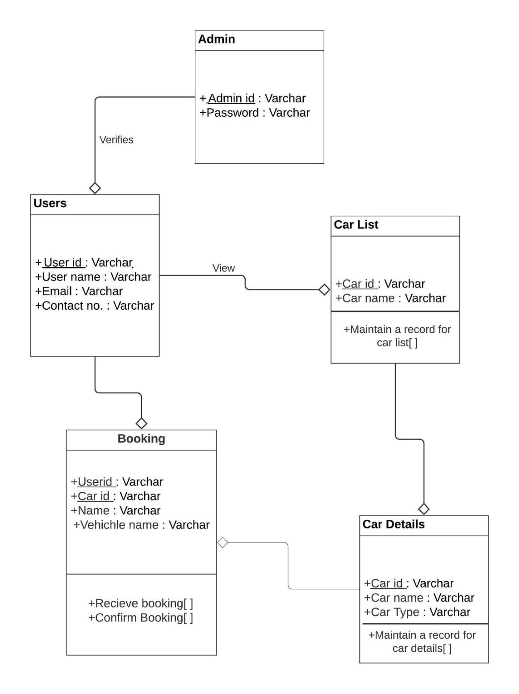**Class Diagram**

**Fig.11.1: Class diagram of OCRS**

Online Car Rental System (OCRS) Class Diagram describes the structure of a different classes, their attributes, operations (or methods), and the relationships among objects. The main classes of the Car Rental System are Cars, Booking, Passenger, Car Routes and Drivers.

* **Details Table**

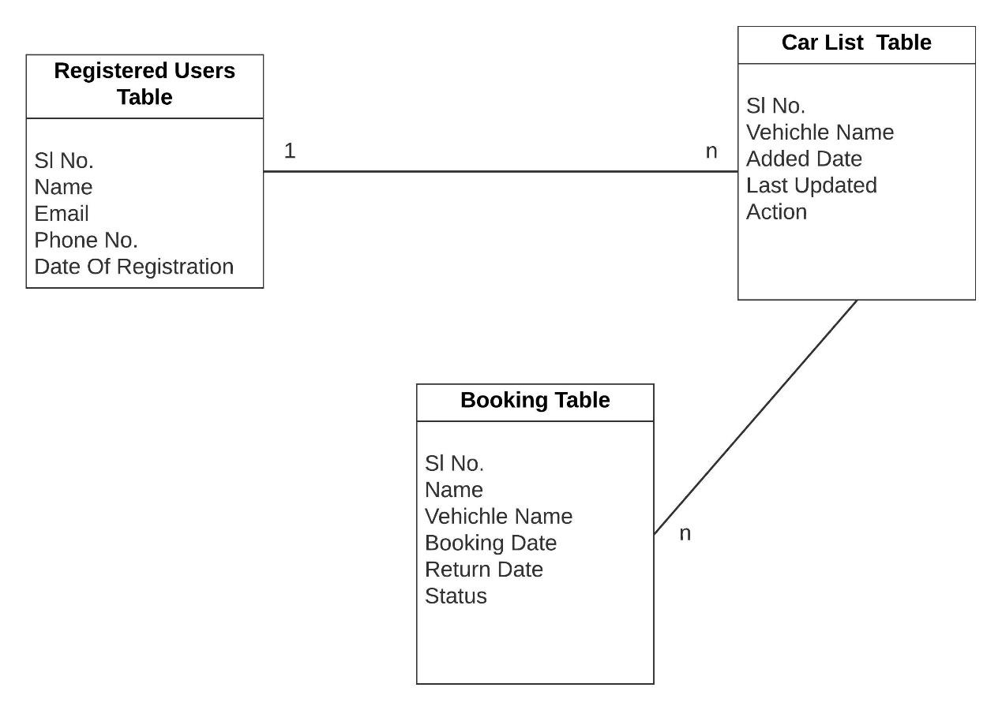

**Fig.11.2: Class diagram of OCRS**

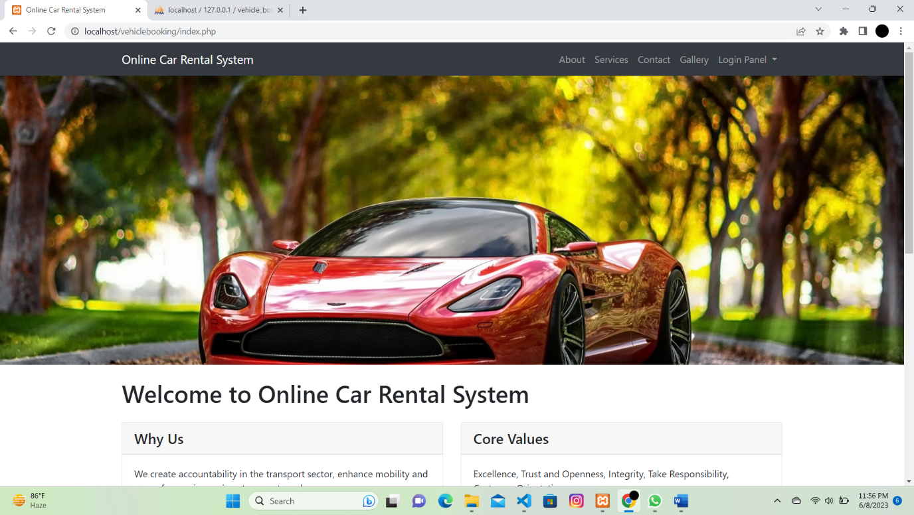**12.SCREEN SHORTS**

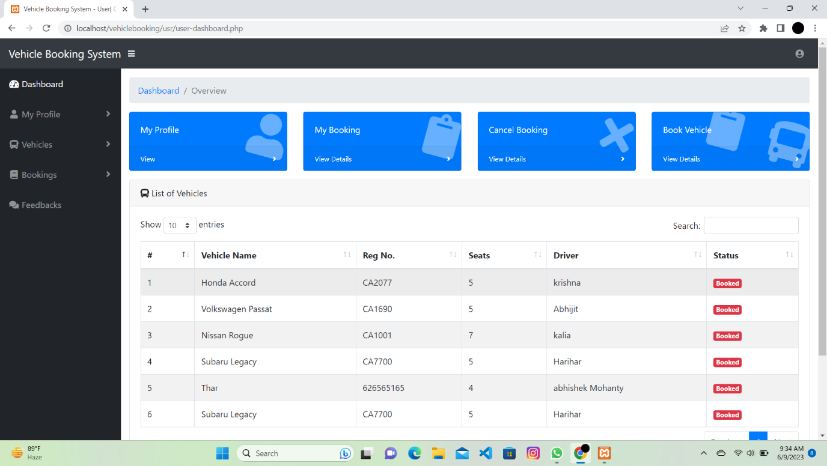

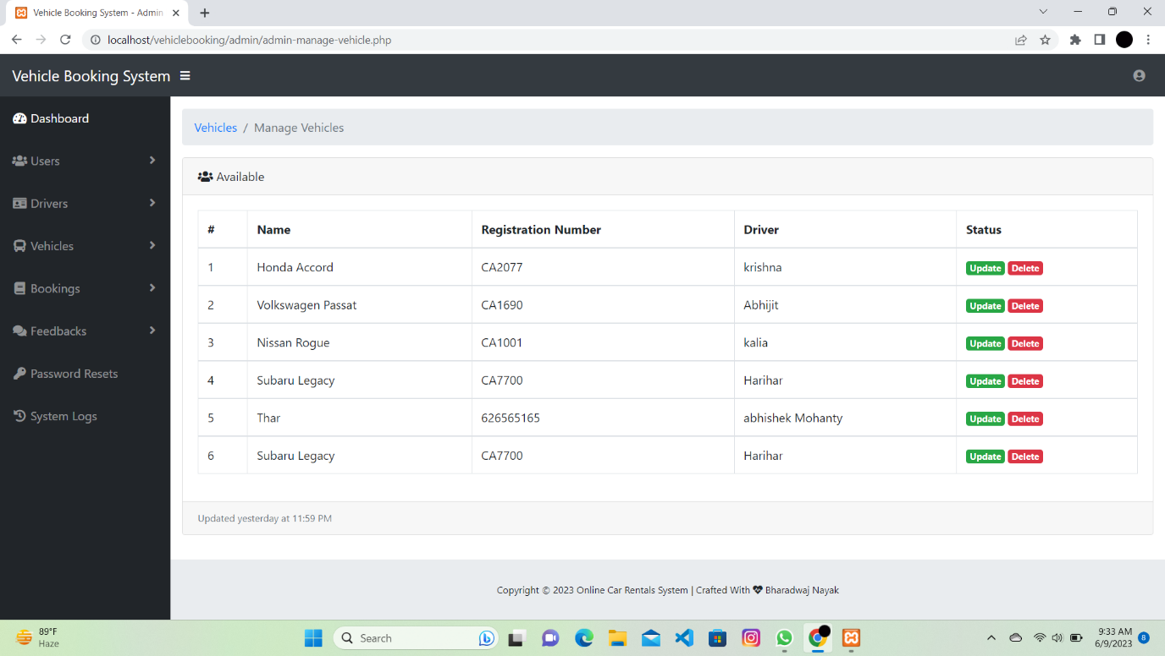

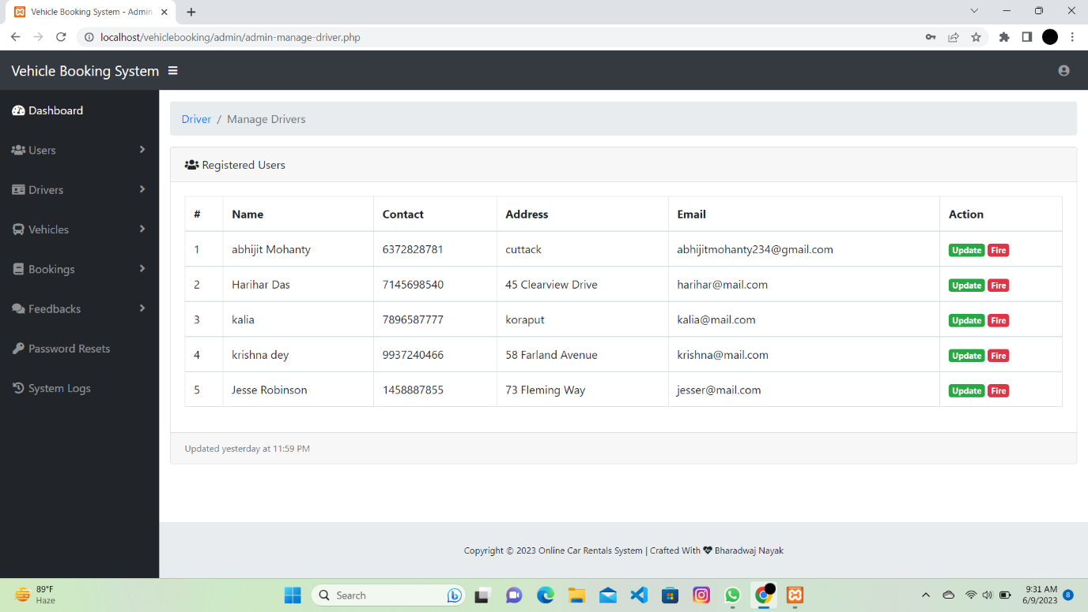

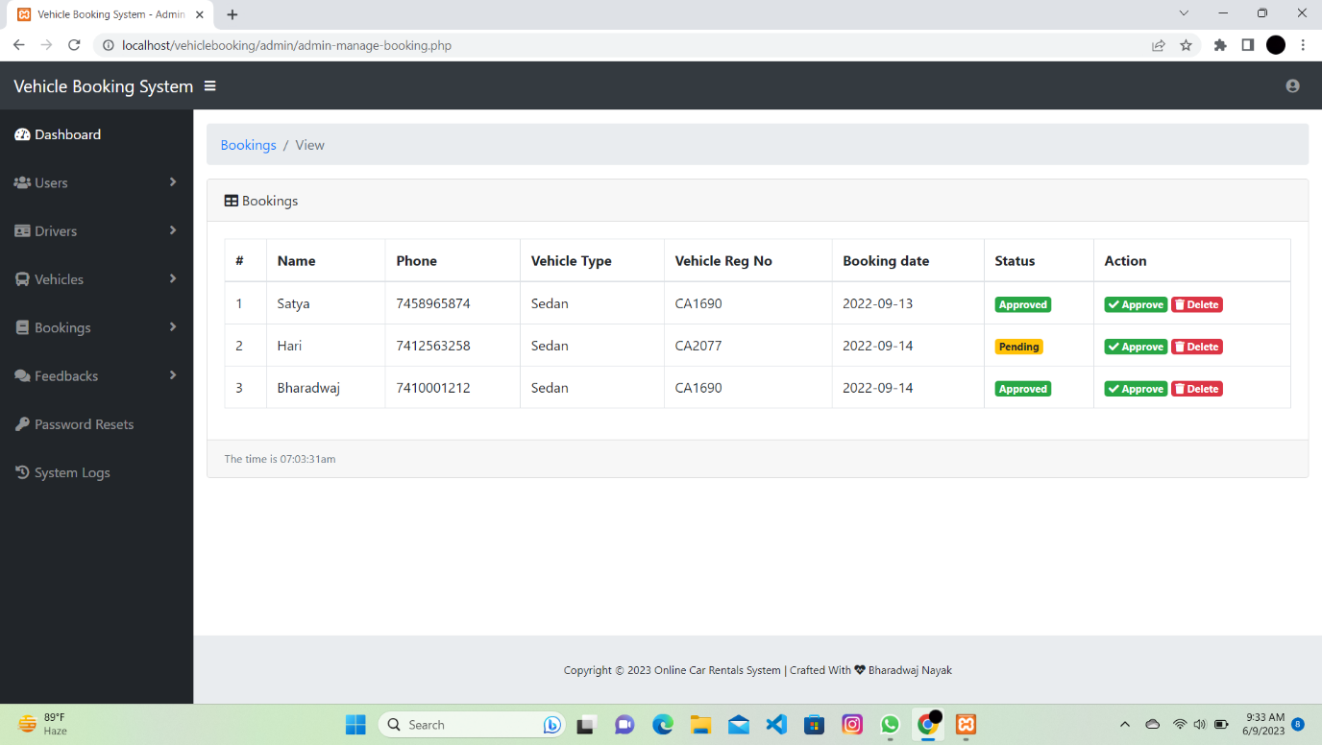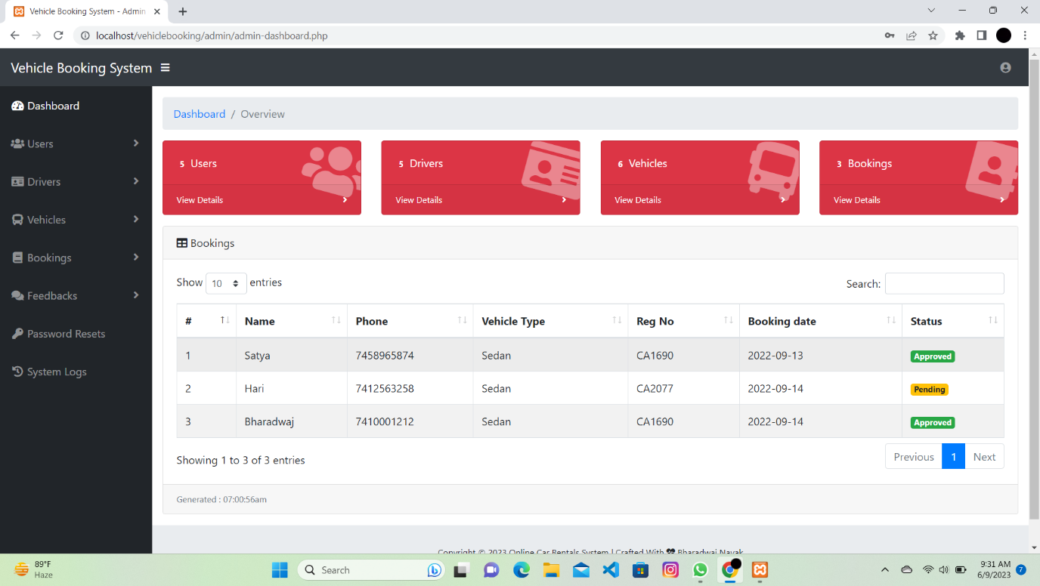

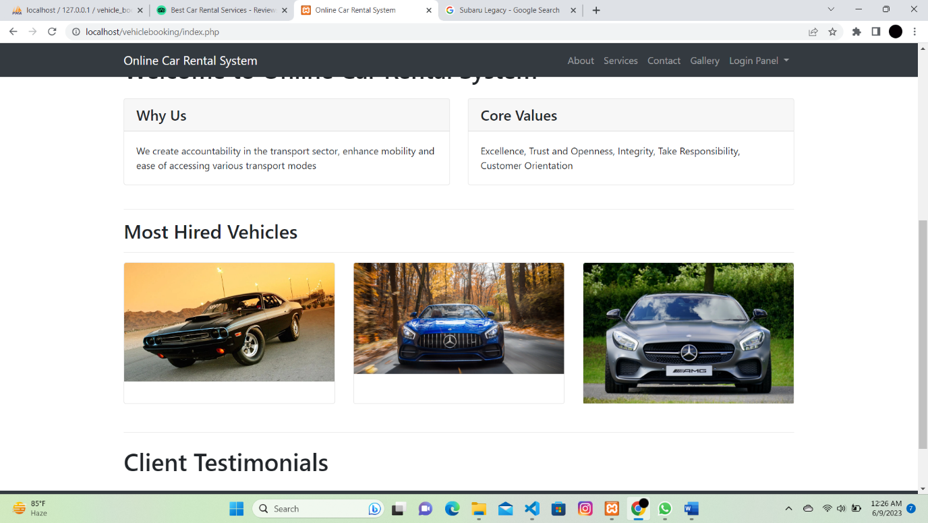

**13.SOFTWARE TESTING**

Testing is the process of evaluating a system or its components with the motive to find whether it meets the required specification or not. It is done for finding the errors, mistakes, identifying any gaps or missing requirements with respect to actual requirements. To get a good quality software we perform testing.

**13.1Black Box Testing:**

* **Admin Section**
* When the application is made to run on the server home page of the admin will open then click on the login in the home page then give valid admin Id and password then click on login button.
* Once the admin login is successful, it will show dashboard page there we have a plenty of options including the Number of booking, registered users, listed vehicles list of brands, Subscribers Queries, Testimonials.
* To edit the listed vehicle click on edit then, edit the vehicle name then click update button, it vehicle, then add brand of the vehicle, then year of manufacturer, model of the vehicle, Then
* select the particular features of the vehicle and click on save.
* To confirm the booking then click on manage booking then select the particular booking and click confirm.
* To change the content of the pages in user side click on manage pages and select the page which
* we want to change the content then type the suitable content and click save.
* To update the contact details, click on update contact details and change the address and click on save.
* **User Section**
* Open the webpage there will be login/register button on the right top corner, click on that and select signup fill out the required columns, then click on signup. Again click on login/register button fill the email id and password then click on login.
* After signing in click on listed vehicles then select the vehicle and click more details then type the from and to date and click on book now.
* To change the password then click on update password on your profile, type new password and click save.
* To send any queries then click on queries option and type your email and message then click on send.
* To see the admin details, click on about us, then we can see the address.
  1. **White Box Testing:**
* **Update password**
* **Change password**
* **Vehicle Details**
* **Contact Us**
* **Car listing**

**14.CONCLUTION**

The world has become a place where there is a lot of technological development; where every single thing done physically has been transformed into computerized form. Nowadays, main target of this project which is about Car Rental System. The system of renting cars exist back in the previous years, were people rent cars for their personal reasons. Car renting is essential to many peoples’ plan to travel or move from one place to another for business purposes, tour, and visit or holidays.

Some car rental companies still use desktop application for their car rental services and thus making it to be limited to so many important feature that are not available unlike in the web based application where there are so many feature available. Also some upcoming companies do not only make use of these desktop applications, but also make use of phone call reservation, which is still lacking so many features that are needed for this type of system.

15.REFERENCES

* Marhayanie, M., Ismail, M., & Muda, I. (2018, January). Impact of Smartphone Features on" Omset" Services Online Car Rental. In *1st Economics and Business International Conference 2017 (EBIC 2017)* (pp. 278-281). Atlantis Press.
* Waspodo, B., Aini, Q., & Nur, S. (2011). Development of car rental management information system. In *Proceedings of The 1st International Conference on Information Systems For Business Competitiveness (ICISBC)* (pp. 101-105)..
* Osman, M. N., Zain, N. M., Paidi, Z., Sedek, K. A., NajmuddinYusoff, M., & Maghribi, M. (2017). Online car rental system using Web-Based and SMS technology. *Computing Research & Innovation (CRINN)*, *2*, 277.
* Danila, D. M., & Gaceu, L. (2010). Online Evaluation Method for Assessing the Variation of the Number of Tourists Interested In Car Rental. *Bulletin of the Transilvania University of Brasov. Series II: Forestry• Wood Industry• Agricultural Food Engineering*, 75-78.
* Nasr, O. A., Miladi, M. N., & Ahmed, M. (2020). CAR RENTAL AND TRACKING WEB-BASED SYSTEM USING GPS. *IJISCS (International Journal of Information System and Computer Science)*, *4*(2), 63-70.